Name : Ansari Ahmed Mohammed Asif
Experiment No 5

Aim: To Study and Implement Platform as a Service using AWS Elastic Beanstalk

1. Introduction to Platform as a Service (PaaS)
Platform as a Service (PaaS) is a cloud computing model that provides a complete development and deployment environment in the cloud. It allows developers to build, test, deploy, and manage applications without worrying about underlying infrastructure such as servers, networking, operating systems, or storage.
In PaaS:
- The cloud provider manages infrastructure.
- The developer focuses only on application code.
- Automatic scaling, monitoring, and updates are handled by the platform.

2. Explanation of Amazon AWS Elastic Beanstalk Service
AWS Elastic Beanstalk is a fully managed Platform as a Service (PaaS) provided by Amazon Web Services for deploying and managing applications in the cloud.
Elastic Beanstalk simplifies application deployment by automatically handling:
- Server provisioning
- Load balancing
- Auto scaling
- Application health monitoring
- Deployment management
- Logging

How Elastic Beanstalk Works
When a developer uploads application code:
- Elastic Beanstalk automatically provisions infrastructure using services like:
  - Amazon EC2
  - Elastic Load Balancing
  - Amazon RDS (optional)
  - Amazon S3
- It deploys the application.
- It monitors application health.
- It automatically scales resources based on traffic.

Key Features of Elastic Beanstalk
- Fully managed service
- Supports multiple programming languages
- Automatic scaling
- Integrated monitoring
- Easy deployment using CLI, Console, or Git
- No additional cost for Beanstalk itself (you pay for underlying AWS resources)

3. Languages and Frameworks Supported by Elastic Beanstalk
Elastic Beanstalk supports multiple programming languages and web application frameworks, including:

1. Java
- Apache Tomcat
- Spring Boot

2. .NET
- ASP.NET
- .NET Core

3. Node.js

4. Python
- Django
- Flask

5. PHP
- Laravel

6. Ruby
- Ruby on Rails

7. Go

8. Docker
- Single-container Docker
- Multi-container Docker
Elastic Beanstalk also supports custom platforms, allowing developers to configure their own runtime environments.

4. Comparison Between EC2 and Elastic Beanstalk
Amazon EC2 is Infrastructure as a Service (IaaS), whereas AWS Elastic Beanstalk is Platform as a Service (PaaS).
Feature | Amazon EC2 | Elastic Beanstalk
Service Model | IaaS | PaaS
Infrastructure Management | Manual | Automatic
Server Setup | User must configure OS, software | Automatically configured
Scaling | Manual or custom configuration | Automatic scaling built-in
Load Balancing | Must configure separately | Automatically integrated
Monitoring | Manual setup required | Built-in health monitoring
Control | Full control over server | Limited control (managed environment)
Use Case | Advanced users needing full control | Developers wanting easy deployment

Summary of Difference
- EC2 gives complete control but requires technical expertise.
- Elastic Beanstalk abstracts infrastructure complexity and focuses on application deployment.

5. Elastic Load Balancing
Elastic Load Balancing (ELB) is a service that automatically distributes incoming application traffic across multiple servers (EC2 instances).

Purpose of Load Balancing
- Prevents server overload
- Improves availability
- Enhances fault tolerance
- Increases scalability

How It Works in Elastic Beanstalk
When traffic increases:
- Elastic Beanstalk automatically adds more EC2 instances.
- Elastic Load Balancer distributes traffic evenly.
- If one instance fails, traffic is redirected to healthy instances.

Types of Load Balancers in AWS
- Application Load Balancer (ALB) – For HTTP/HTTPS traffic
- Network Load Balancer (NLB) – For high-performance TCP traffic
- Classic Load Balancer – Older generation
Elastic Beanstalk automatically configures and integrates load balancing when deploying scalable applications.

Implementation Steps
1. Access AWS Elastic Beanstalk Navigate to the Elastic Beanstalk service in the AWS Console and click "Create application" to begin.
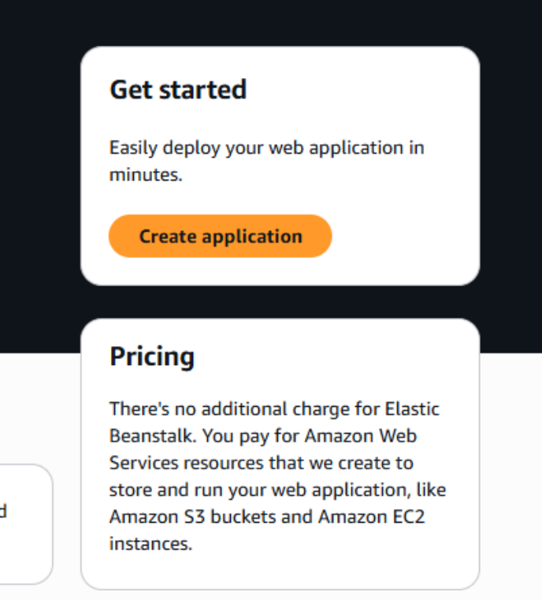
2. Configure Environment and Platform Select "Web server environment" and name your application (e.g., "AhmedApp"). Choose "PHP" as the platform and select "Sample application" under the Application code section to deploy a default test page.
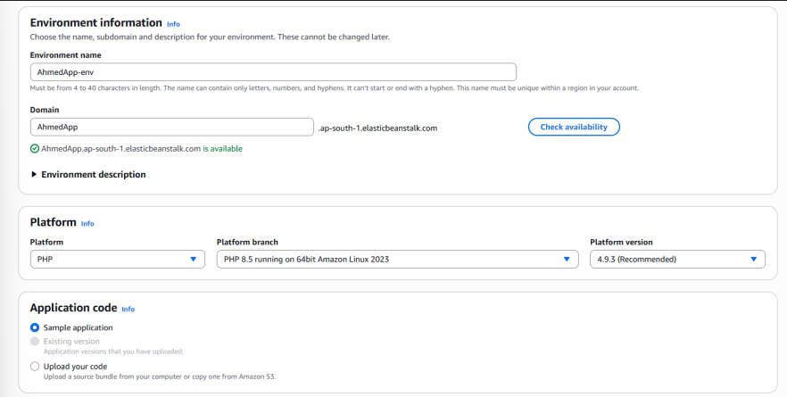
3. Configure Service Access Set up your IAM roles to grant Elastic Beanstalk the necessary permissions. Create or select a service role and an EC2 instance profile (e.g., "AhmedManager").
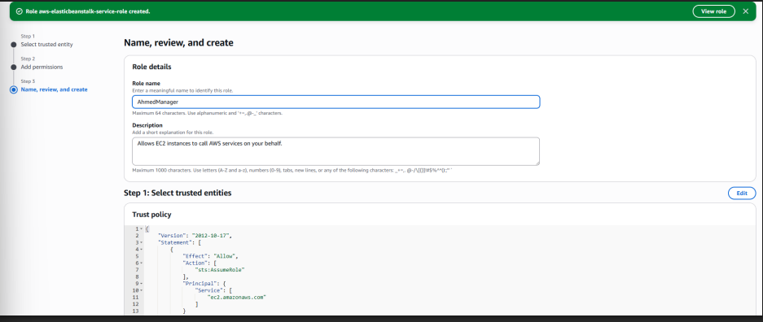
4. Set Up Networking Select your default VPC and choose the specific instance subnets (Availability Zones) where your environment will be deployed.
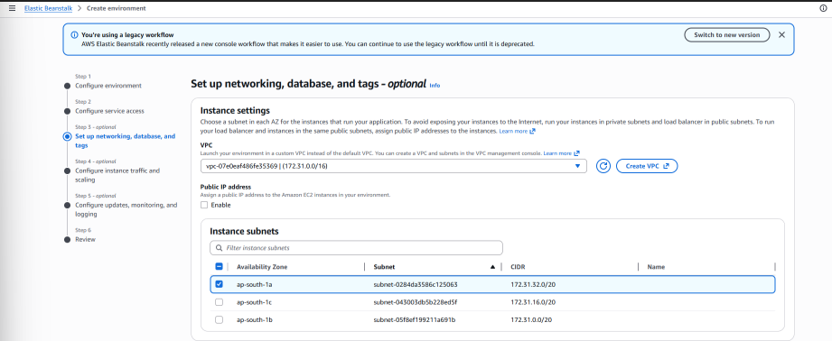
5. Configure Instance Capacity Under the Capacity settings, choose a "Single instance" environment to minimize costs. Set the instance type to "t3.micro".
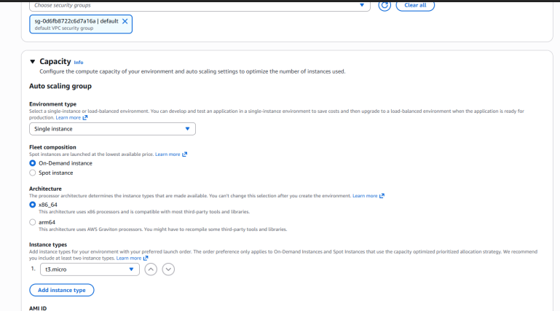
6. Review and Launch Review your configuration choices—ensuring your platform, application code, and service roles are correct—and submit to create the environment.
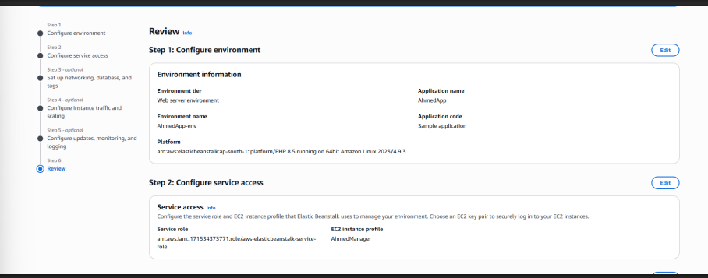
7. Monitor Deployment Watch the Environment overview screen. The deployment is complete when the Health status changes to "Ok" and the events log reads "Successfully launched environment".
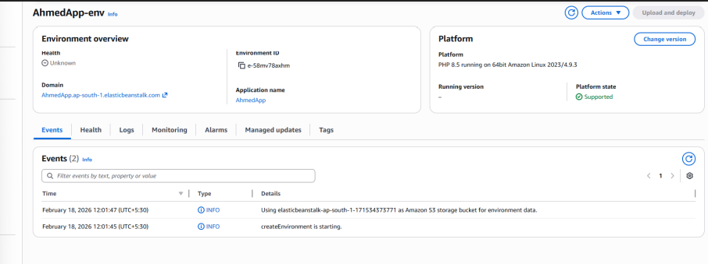
8. Verify Application Deployment Click the generated Domain link under the Environment overview. This opens a new tab displaying the "Welcome to Your Elastic Beanstalk Application" page, confirming a successful PaaS deployment.
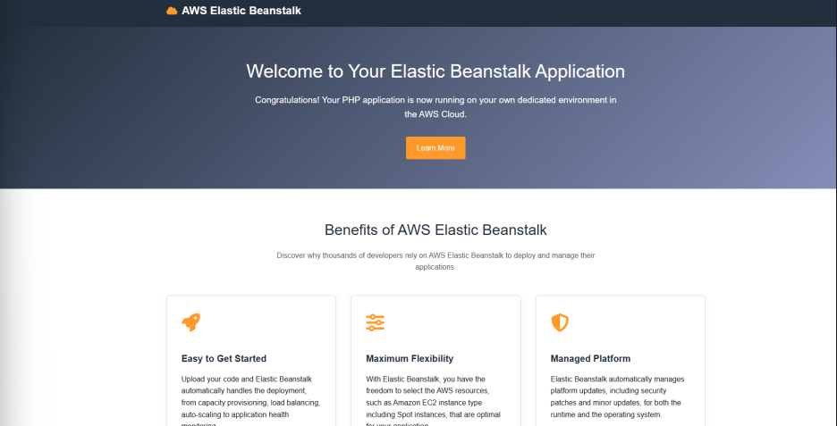
9. Clean Up Resources To avoid ongoing charges, navigate back to your Applications list and confirm the deletion of your application, which will permanently terminate the environment.
